### §5 Protein Function

主要内容：关于Hb的一堆内容（？）

1. Mb的结构
2. 引入：生物体运氧面临的问题

Pr侧链亲和力低，过渡金属元素与氧结合在溶液中产生自由基，heme（亚铁血红素）的亚铁容易氧化——用heme结合氧气并包裹在pr里——globins

Myoglobin (storage), hemoglobin (transport), leghemoglobin(soybean)（豆血红pr）

1. 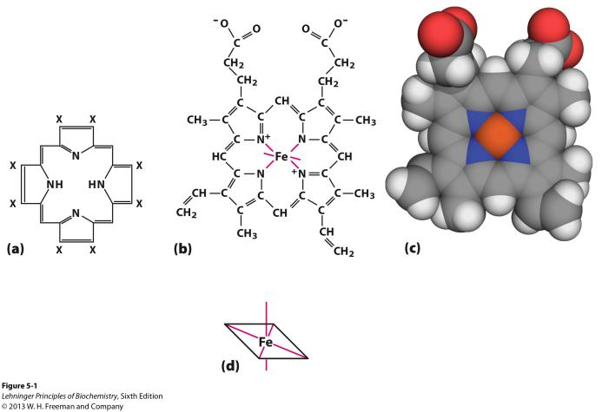heme结构：卟啉环，中间Fe2+（中间Mg叶绿素）

几乎位于一个平面

1. A cylindrical model of myoglobin shown with His residues. The alpha helices are shown as white cylinders labeled A to H. Bends, which are thin, white connectors, are labeled with two letters according to the helices they connect. Helix A is horizontally oriented, with bend AB emerging from its right end and connecting to Helix B. Helix B is oriented vertically and leaning slightly left. There is no labeled bend for BC, because no residue exists there. Helix C is oriented end-first toward the viewer, with bend CD emerging from the front end and curving to the right, looping up and down before connecting to Helix D, which is shorter and vertically oriented with the lower end tilted slightly toward the viewer. Bend DE is short and curves slightly to the left to connect with Helix E, which is oriented lengthwise toward the viewer, with the left end tilted downward. To the far left end of Helix E, bend EF is very short and connects with Helix F, which is oriented vertically with a slight tilt to the right. Bend FG extends from the top of Helix F away from the reader to connect with Helix G, which is diagonally oriented and tilted downward on the right side. It is located behind all the other helices. Just below Helix E, bend GH is visible. It curves downward from Helix G and upward to join with Helix H, which is oriented diagonally, with the right side tilted down and slightly away from the viewer. At the end of Helix H, closest to the viewer, is a residue labeled "carboxyl terminus." At the leftmost end of Helix A is the label "amino terminus." These His residues are located on Helices E and F.  His64 is labeled and located on Helix E, and is shown as a white ball-and-stick model that bends toward the center of the protein where the heme group is situated. His 93 (His F8) (labeled on the helix) is on Helix F. It is shown as a ball-and-stick closed ring structure, also oriented toward the center of the protein and the heme group. Between the two His residues, the heme group (red) is suspended. It is oriented vertically and contains an orange ball within it, representing iron. structure of Mb：

如图，8个α-helix

近端组氨酸 His F8结合亚铁离子，亚铁离子与氧气形成配位键

远端组氨酸 His E7与氧气形成氢键

Ps.氧气分子不与heme平面垂直，而是成一定的角度

1. Hb结构
2. α2β2，每个亚基类似Mb，4个氧气结合位点
3. T态、R态转变：T tense low affinity（低亲和力） R relaxed high affinity（高亲和力）

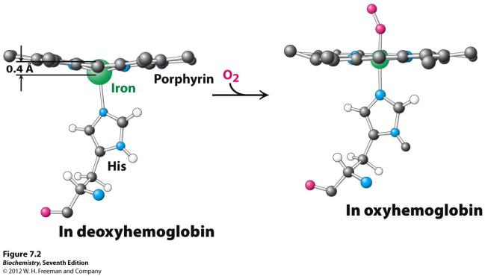 T态时有更多盐键存在于α1-β2和α2-β1之间

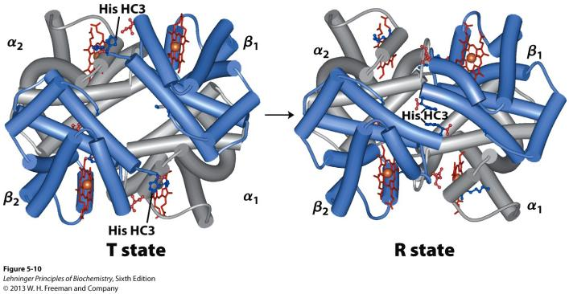

近端His使Fe稍微离开卟啉环平面，氧气的结合导致亚铁离子被拉回卟啉平面，并带动蛋白质构象变化，使T态转变为R态

1. 正协同效应（Cooperativity）：一个normal ligand的结合导致蛋白质构象变化，使得其他位置更容易结合配体

Allosteric regulation（别构调节）：Binding of a ligand(配体) to one site affects the binding properties of a different site on the same protein.It can be positive or negative.

Homotropic：The normal ligand of the protein is the allosteric regulator.Including **positive and negtive** homotropic regulation.

Cooperativity = positive homotropic regulation

Heterotropic：A different ligand affects binding of the normal ligand.Including **positive and negtive** heterotropic regulation.

1. Hill方程
2. 配体结合的定量描述

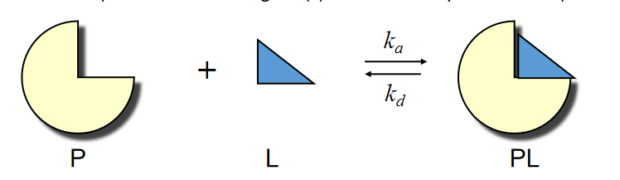ka结合**速率** kd解离**速率**

*ka*[P][L]  *kd* [PL]

Ka结合平衡**常数** Kd解离平衡**常数**

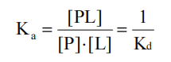

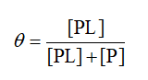用来表示被结合了的P占总P浓度的比例

结合Kd的方程一波推导得

Kd的生物学意义：当有一半P被占据时的自由配体浓度

Kd升高，亲和力下降；Kd降低，亲和力上升

由于实验时一般使用过量配体，所有自由配体浓度近似于总配体浓度

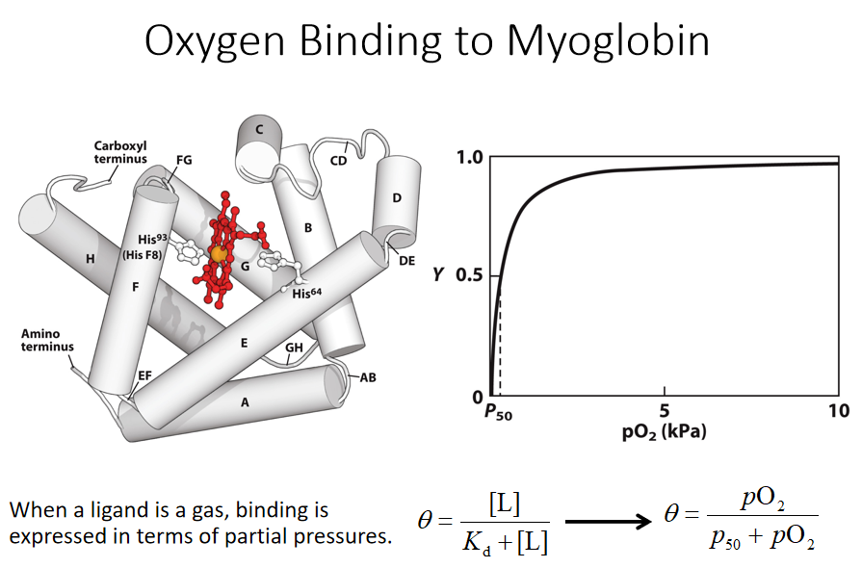

1. 协同效应与希尔方程

假设n个配体同时与P结合，有

 Hill equation

nH = 1, the binding is not cooperative;

When nH >1, the binding is positively cooperative;

When **nH <1**, the binding is negatively cooperative.

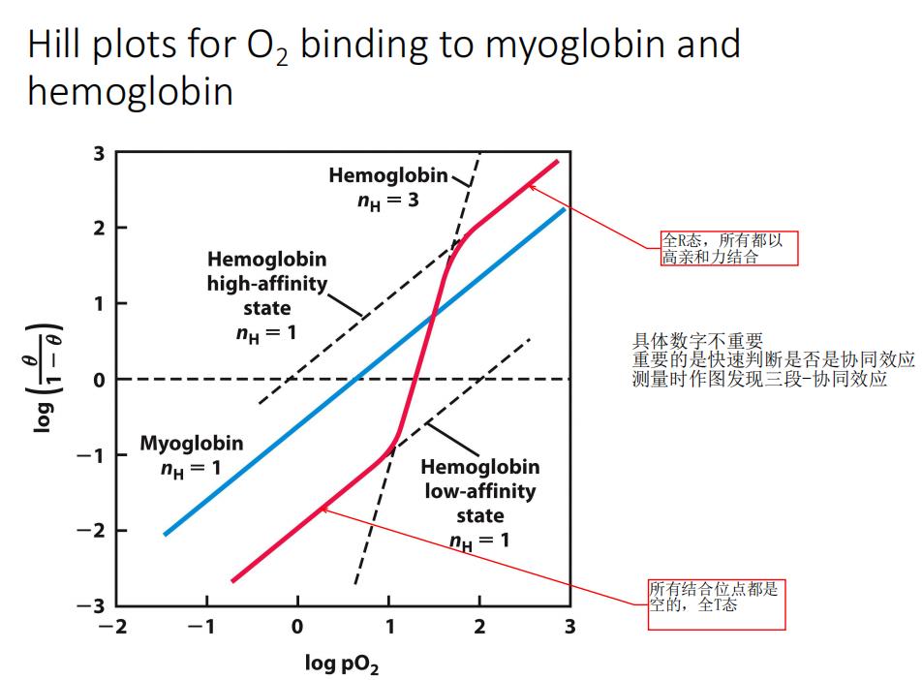

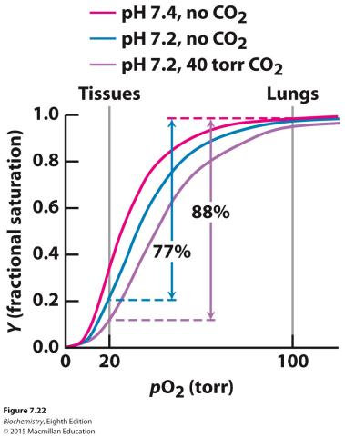

1. 其他影响氧气结合的因素
2. Bohr effect：pH下降（H+浓度增加），CO2浓度增加，Hb与氧气亲和力降低

40%H+用Hb运（结合His），15%-20%CO2用Hb运（氨甲酰血红蛋白）

原理：Binding of H+ and formation of the carbamate lead to the formation of additional salt bridges, stabilizing the T state.（形成更多盐桥，稳定T态）

1. 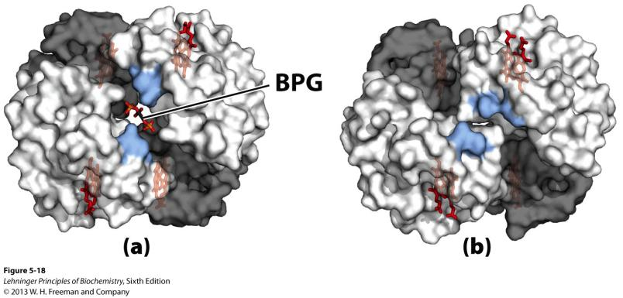2,3-BPG：2,3-BPG binds to the central cavity of Hb and stabilizes the T state.

2,3-BPG是EMP的副产物，表示组织缺氧，促进Hb放氧

短期适应高海拔，机体通过增加2,3-BPG含量促进放氧

1. 亚基的改变

胎儿血红蛋白为α2γ2，无法结合2,3-BPG，对氧气有更高的亲和力，能够从母体获取氧气

1. CO中毒

CO对游离heme的亲和力比O2高20000倍（三键的存在使结合能力更强）

但是CO只能与卟啉环平面垂直结合亚铁，在globin中远端组氨酸产生空间位阻阻止结合，o2双键柔软可以成一定角度，还能形成氢键，故globin中CO亲和力只比O2强200倍

CO结合稳定R态，使其他亚基就算能结合O2也无法释放O2

1. 镰刀型细胞贫血

β链G6V，疏水作用使Hb聚合成长条形，运氧能力下降